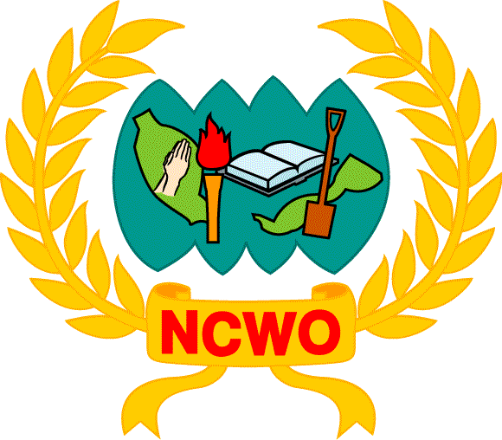

NO KIDDIE PACK, EVERY LIFE COUNTS

MEDIA STATEMENT
by
Professor Emerita Tan Sri Dato’ Seri Dr. Sharifah Hapsah Syed Hasan Shahabudin
President
National Council of Women’s Organisations, Malaysia

NCWO lauds the Malaysian Government for instituting numerous achievements in tobacco control and in ratifying the WHO Framework Convention on Tobacco Control (FCTC) IN 2005. In 2010 the Government also took a strong stand in banning the sale of small cigarette packs also known as “kiddie packs”. This is clearly in line with Article 16.3 of the Convention which states that: “Each Party shall endeavour to prohibit the sale of cigarettes individually or in small packets which increase the affordability of such products to minors.”

Regretfully, it is observed in these past few weeks that there has been pressure on the Government to bring back the sale of “kiddie packs” to combat the increasing sale of illicit cigarettes. The adoption of this possible undesirable action is a clear violation of the FCTC Article 5.3 where public health policies with regards to tobacco control is being interfered by entities of commercial and vested interest. NCWO is of the view that the government should not be put under such pressure for the following reasons.

- The evidence is staggering - tobacco kills one person every six seconds – that is, 1 in 10 deaths among adults worldwide; accounting for 500 million deaths a year. By 2030, unless urgent action is taken, tobacco’s annual death toll will rise to more than eight million. WHO in its Global Tobacco Epidemic Report 2008 warns us that if current trends continue unchecked, tobacco could kill up to one billion people in this century.

- Everyday 50 teenagers in Malaysia begin smoking and of the 4.7 million smokers in Malaysia, most start before the age of 18; with 25% before the age of 10. A study on Juvenile Delinquency carried out by the Malaysian Crime Prevention Foundation showed that cigarette smoking offence (87%) is the top of the seven offences among delinquent children. Making cigarettes affordable for our youth and children will clearly result in far greater repercussions than we can imagine.

- Every year more than 20,000 Malaysians are killed by tobacco related diseases. Studies show that more men and women die in Malaysia from tobacco related diseases than on average in middle income countries. What is more alarming is that you don’t need to be a smoker to be at risk. The Global Adult Tobacco Survey 2012 on Malaysia revealed that four out of 10 adults were found to be exposed to second-hand smoke at home (7.6 million adults), and four out of 10 were found to be exposed to second-hand smoke indoors at their workplace (2.3 million adults). Among those adults who visited a restaurant in the past 30 days, seven out of 10 would have been exposed to second-hand smoke (8.6 million adults).

- Another critical area of consideration is economics. Tobacco use reduces overall national incomes by up to 3.6%. At the society level, direct costs are estimated from public and private medical costs of treating cigarette related diseases. According to a study reported in Bernama in 2007, three smoking-related illness diseases namely, ischemic heart disease, lung cancer and chronic obstructive pulmonary diseases has consumed about RM3.5 billion of Malaysia’s health care costs.

- More importantly, a 2007 study demonstrated that retailer compliance with laws limiting sales to minors appears to be significant in reducing youth access to cigarettes. In fact the Government’s 2012 International Tobacco Control Report, stated that tobacco taxes and prices have not increased at a rate high enough to offset income growth, so cigarettes are becoming more affordable to consumers. We must persist with the Government’s recommendation that the price must be kept high through taxation as this works as a measure to help smokers to quit and also as a deterrent to young people.

As a nation, we simply cannot turn our backs on the responsibility of protecting our youths and children from any kind of clear threat to their lives. Evidence from several studies suggest that the observed decline in many countries in coronary heart disease mortality, one of the most important non-communicable diseases in terms of burden of disease is through prevention, rather than treating the consequences of disease. This means mitigating risk factors such as tobacco use.

Instead of introducing kiddie packs, NCWO calls on the Government to formulate strategies to combat the illicit market such as introducing and restricting licenses to premises for the sales of cigarettes and to conduct rigorous pack evaluation studies to monitor the extent of illicit trade activity.

The compelling evidence of the loss of life and the health cost implications along with the strong call of the people to safeguard the health and lives of their families summon our collective attention. NCWO is confident that the Government will hold fast to its 2010 decision to ban kiddie packs and take the necessary measures to stand by and fulfil its obligations to the people.

For further information, please contact:
Omna Sreeni-Ong
Hon Secretary General
National Council of Women’s Organisations, Malaysia
+6012 2077947
ncwohq@gmail.com

