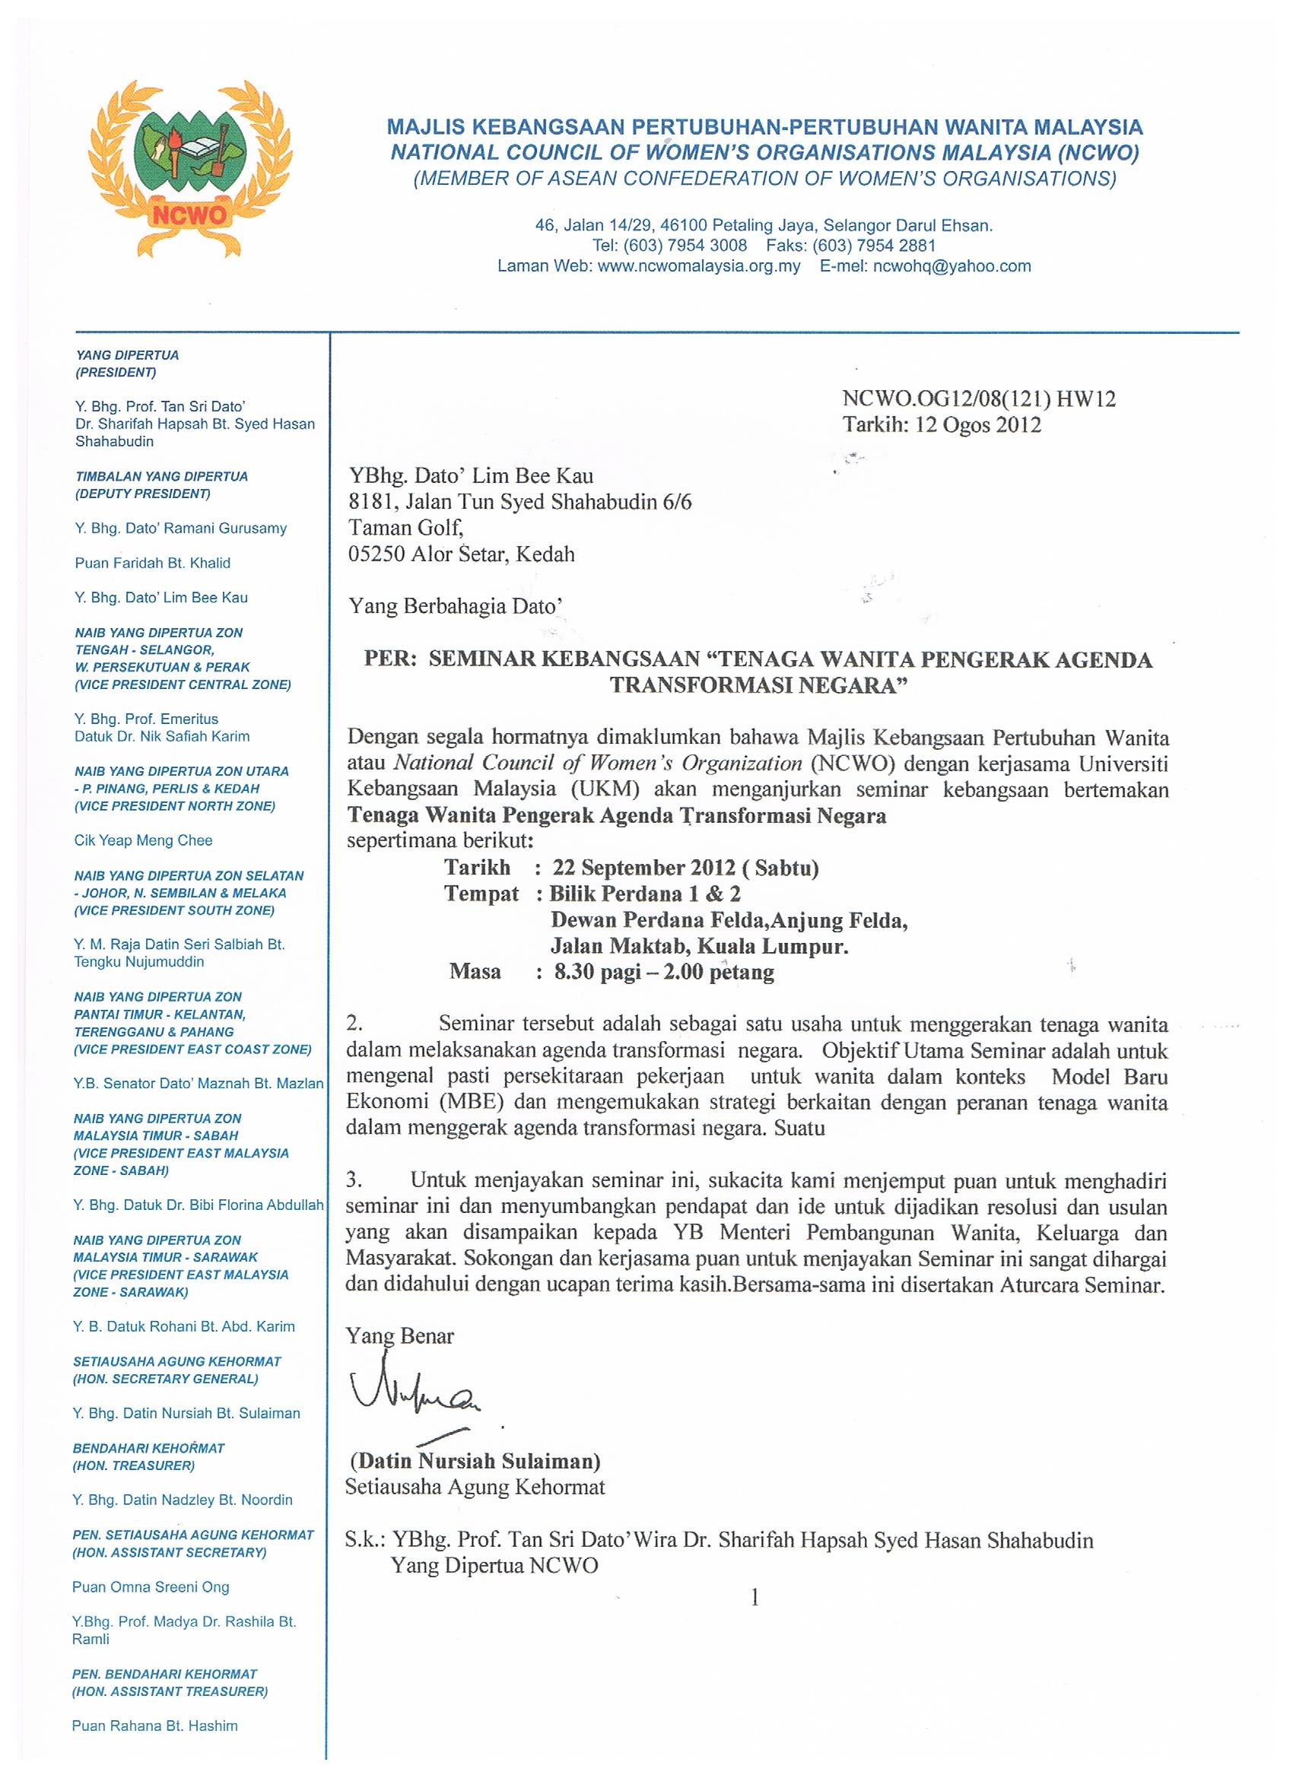

STATEMENT ON REFORMS FOR GENDER EQUALITY

Distinguished Members of the Council of Eminent Persons

The National Council of Women’s Organisations, Malaysia (NCWO) is pleased to extend to you our greetings and the well-wishes of our coalition comprising more than 150 national and local women’s organisations across Malaysia.

At this unprecedented and exciting juncture in the history of our nation, NCWO together with its constituent members representing different ethnicity, ideology, beliefs and socioeconomic background but with the common interest of advancing women’s rights and equality, stand in unity with the Government to work towards a prosperous and harmonious Malaysia.

Since our inception in 1963, NCWO has been resolute in its advocacy for the advancement of women and gender equality. Recognising the disadvantage that women face as a result of deeply ingrained cultural and traditional norms, including misinterpretation of religious texts, NCWO’s advocacy over the years has been focussed on: (a) reforming discriminatory legislations, policies and practices to ensure gender mainstreaming in all areas of development through the support and capacity building of national machineries and (b) working with the women themselves on programmes for empowerment.

While Malaysia has taken great strides in advancing the status of women, especially in areas such as health and education, there is yet much to be done to address direct and indirect discrimination which continue to impede the full development and engagement of women as equal protagonists in society. We would like to highlight the premises and put forward our recommendations to end all forms of discrimination against women for your consideration :

Premise
- Agenda 2030 and the Sustainable Development Goals (SDG) clearly call for a transformative approach to sustainable development and an end to all discrimination against women and girls. Sustainable development cannot be achieved without laws that enable women to reach their full potential. The 2030 Agenda highlights the need for the removal of “legal, social and economic barriers to [women’s] empowerment” and Goal 5 calls for collective action in creating conducive environments for the realisation of substantive equality of women and men in both public and private spheres of life.

- The Convention on the Elimination of All Forms of Discrimination Against Women (CEDAW) is an international instrument which provides States with an agenda for national action to address the persistent nature of inequality and discrimination. Malaysia ratified CEDAW in 1995, submitting itself to the periodic review of its implementation of the articles of CEDAW. The periodic review allows the country to regularly examine its status as it steadily advance towards gender equality by realigning to the CEDAW Committee’s concluding observations and recommendations. Malaysia submitted its first report in 2005 and the NGO Shadow Report was prepared by NCWO and its associates. The combined 3rd to 5th periodic reports was finally submitted in September 2016. In delaying its report, Malaysia has lost many years in the continuum towards gender equality. At its recent meeting with the CEDAW Committee in February 2018, the Government received a dim review of the status of its implementation of CEDAW in Malaysia. The NGO Shadow Report also presented gaps and shortfalls in the country’s status on equality and non-discrimination.

- The National Policy on Women was developed as a strategy to implement CEDAW, Beijing Platform for Action (BPfA) and the SDGs. The Ministry of Women, Family and Community Development (KPWKM) through its Department of Women Development is the current primary advocate in government to empower women and advance gender equality. Gender Focal Points (GFPs) were appointed in every Ministry and Gender Responsive Budgeting was also instituted in 2004 together with the Ministry of Finance. However, as a line Ministry it lacks the capacity and clout to influence other line Ministries to undertake gender mainstreaming and to address gender inequalities. Further, it is hampered by a high turn-over rate of key officers, lack of understanding of gender concepts among staff, lack of a strategic approach in planning and implementation as well as lack of a clear roadmap and outcomes for monitoring.

- Since 2016 NCWO has advocated for greater coherence in addressing law reforms among women’s groups as well as with Government. This has resulted in the formation of the NCWO / JAG law reform working group. To its credit, the Ministry of Women, Family and Community Development (KPWKM) has established the Joint Law Reforms Committee in 2017 which include members from NCWO and the Joint Action Group (JAG). The institutionalisation of the government / civil society partnership has enabled a comprehensive review of all legislations that affect women and girls. The current focus of the Joint Law Reforms Committee is the drafting of Bills to address Gender Equality and Sexual Harassment.

- While Government has opened up spaces for joint consultations with NGOs, it is merely on an ad-hoc basis with no clear commitment to work together. NGOs are touchpoints at the grassroots and are effective community mobilisers. They are powerful resources with experience, expertise and passion. If engaged efficiently, they can help accelerate in advancing processes towards gender equality.

- Through the strong advocacy of NCWO and other women NGOs in Malaysia, discrimination against women in the context of our legislative system continues to be highlighted resulting in greater government attention to legal reforms for women and girls. This includes issues related to Muslim Family Law, hudud and conversion of minors. A greater challenge is the need to address the underpinning issues of deeply ingrained and often nuanced cultural and traditional norms , as well as personal beliefs which creep into government and public practices that continue to discriminate against women.

Recommendations
- The term “discrimination” must be clearly defined in the Federal Constitution based on human rights and justice and not left to the interpretation of the courts and government.
- The Joint Law Reforms Committee of KPWKM must speed up actions to:
  - to repeal, amend or enact laws such as the Sexual Harassment Act to safeguard the rights of women and girls and provide them sufficient protection and recourse.
  - enact the Gender Equality Legislation to eliminate sex and gender discrimination, provide for the comprehensive realisation of substantive equality of women with men in both public and private spheres of life and set in place strong accountability mechanisms which promote, monitor and enforce gender equality.

- Gender mainstreaming programmes need to be intensified for institutional capacity building to ensure that CEDAW is domesticated into laws, policies, strategies, programmes and practices in all sectors and at all levels of government. Partnership with women’s groups need to be institutionalised to ensure a more holistic planning and implementation of the CEDAW. Only in this way can CEDAW truly become the benchmark and goal for equality and non-discrimination.

- Institutionalise government / civil society partnerships for development, much like the KPWKM-NCWO collaborative agreement signed in 2016 and allocate budget appropriately. The collaboration has enabled consultation and pooling of financial resources on all areas of planning, implementation, monitoring and evaluation of policies and programmes.

- Most importantly, a monitoring mechanism has to be established under the Deputy Prime Minister to ensure proper implementation and reporting across all government ministries and agencies that fulfil the State’s will and obligation to gender equality. Gender is a cross-cutting issue and gender equality has a direct impact on the achievement of national development goals.

Yours sincerely
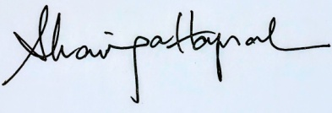
Prof Emerita Tan Sri Dato Seri Dr Sharifah Hapsah
President of NCWO

